

Force and Pressure

1. Which of the following statements are true?
   1. An object will continue moving uniformly until the resultant force on it is zero.
   2. The bodies do not change their state of rest or motion unless acted upon by an unbalanced external force.
   3. If a body is at rest on the surface of the Earth then the net downward force exerted by the Earth and net upward force exerted on the body are not equal to each other.
      1. Only (i) and (ii) (2) Only (ii) and (iii)

(3) Only (i) and (iii) (4) All (i), (ii) and (iii)

1. Match the column I with column II and select the correct option from the codes given below.

|  |  |
| --- | --- |
| **Column I** | **Column II** |
| (A) A girl pulling the leash of a running dog | (i) Impact force can make stationary object to move by an another moving  object. |
| (B) A driver turning  the steering wheel of a car | (ii) Gravity acts upon an object |
| (C) When you hit a  nail with a hammer | (iii) Force can make  an object go slower |
| (D) A ball released from top of a tower | (iv) Force can change  the direction of a moving object. |

1. (A)-(i), (B)-(ii), (C)-(iii), (D)-(iv)
2. (A)-(iii), (B)-(iv), (C)-(i), (D)-(ii)
3. (A)-(ii), (B)-(i), (C)-(iv), (D)-(iii)
4. (A)-(iv), (B)-(iii), (C)-(ii), (D)-(i)
5. The surface area of the base of a brick X is 100 cm2 . The surface area of the base of the brick Y is 250 cm2 . Each brick weighs 100 N.

Which of the following is correct if P and P are

1. When we walk on sand our feet sink into it and it is difficult for us to walk but a camel can easily walk on sand because
   1. The weight of the camel is the force that is spread over the large area covered by its feet.
   2. The pressure exerted by the camel's body on the sand is very large.
      1. Only (i) is correct.
      2. Only (ii) is correct.
      3. Both (i) and (ii) are correct and (ii) is the conclusion of (i).
      4. Both (i) and (ii) are correct and (i) is the conclusion of (ii).
2. There are three tins filled with water and have holes of the same size as shown in figure. Which of the following options is correctly identifies true

(T) and false (F) for the given statements?

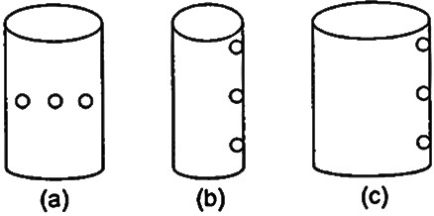

1. The farthest spout is from the middle hole in case (a).
2. The stream of water falls out the farthest through the upper hole in case (b).
3. The farthest spout is from the lowest hole in case (c).

|  |  |  |  |
| --- | --- | --- | --- |
|  | **(i)** | **(ii)** | **(iii)** |
| (1) | T | T | T |
| (2) | F | T | T |
| (3) | F | F | T |
| (4) | F | F | F |

1. The diagram shows an object hanging from a string. Which of the following is the correct

1 2 statement about the diagram?

the pressures exerted by the bricks X and Y respectively?

(1) *P*1  *P*2

(3) *P*1  *P*2

(2) *P*1  *P*2

(4) *P*1  *P*2  0

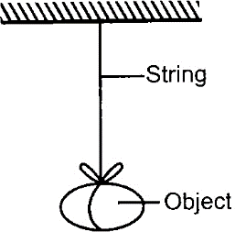

1. The object does not fall because there is no gravity.
2. The object does not fall because there is friction between the object and the string.
3. The object does not fall because a magnetic force is acting on it.
4. The object does not fall because the string is exerting a force against the Earth's gravity.
5. The diagram shows a simple mercury barometer. The mercury level is at a height h when the atmospheric pressure is 100000 Pa. What is the pressure at P?

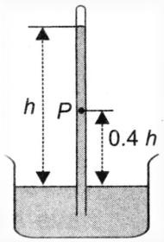

(1) 40000 Pa (2) 60000 Pa

(3) 100000 Pa (4) 140000 Pa

1. As we go higher up on mountains, our ears pop because
2. Air pressure around our ears increases
3. The pressure exerted by the blood near ears increases
4. Air pressure around our ears decreases
5. None of these
6. In the given figure, a beaker is filled with water. A, B and C are three holes in beaker, which of the following statements is correct regarding this?
7. The water comes out with maximum pressure from hole A.
8. The pressure of water comes out from hole B is greater than the pressure of water comes out from hole C and hole A.
9. The water falls out the farthest through the hole C.
10. The water falls out the nearest through the hole B.
11. What will happen if there is a vacuum just above one limb of the U-tube half filled with liquid as shown in figure?

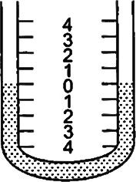

1. The liquid will rise up in the limb where a vacuum just above and move down the other.
2. The liquid will move down in the limb where a vacuum just above and rise up the other.
3. The liquid will move down in both the limbs of U-tube.
4. The liquid will rise up in both the limbs of U- tube.
5. A wooden block is floating in water contained in a beaker. If the beaker is placed in a free falling elevator, during the free fall, the up thrust on the block will be
6. Equal to the weight of the block
7. Slightly more than the weight of the block
8. Slightly less than the weight of the block
9. Zero.
10. In the given diagram, when a weight of 100 g is hung from the spring, its length is 9 cm. When a weight of 150 g is hung from it, its length is 11 cm. What is the length of the spring when there is no weight hanging from it?

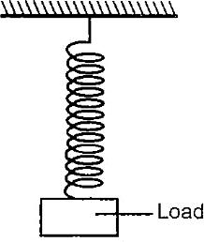

(1) 2 cm (2) 4 cm

(3) 5 cm (4) 7 cm

1. Jay and Puneet go to the amusement park to play the pin ball game. The figure shows the extent to which each of them pulls the striker. Which one of the following statements is correct?

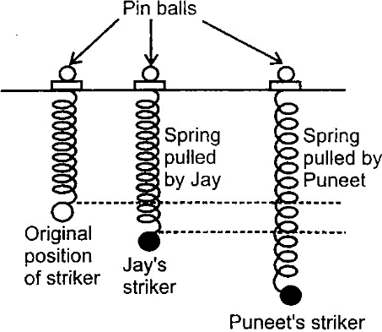

1. Jay's ball will move faster because spring of his striker is more elastic.
2. Puneet's ball will move faster because the spring of his striker is more elastic.
3. Jay's ball will move faster because the spring of his striker stores more potential energy.
4. Puneet's ball will move faster because the spring of his striker stores more potential energy.
5. Does a falling body accelerate? Why?
6. Yes, because the gravity is a force that causes it to move faster.
7. No, because the gravity is a force that causes it to move at constant speed.
8. Yes, because the air causes it to accelerate.
9. No, because air keeps it moving at constant speed.
10. 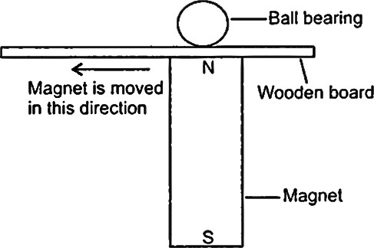A boy set up an experiment as shown in the diagram. As he slide the magnet across the wooden board, the ball bearing followed the magnet's movement and direction. What does the experiment show?
    1. Magnetic force can be seen due to friction between ball bearing and wooden board.
    2. Friction and gravity help to move the ball bearing.
    3. The ball bearing is made of a magnetic substance.
    4. Magnetic force can pass through the wooden board.
       1. (i)and(ii) (2) (iii) and (iv)

(3) (i), (iii) and (iv) (4) (ii), (iii) and (iv)

# Achievers Section (HOTS)

1. A sharp knife enable us to cut through things more easily as compare to the blunt knife because
2. The pressure exerted is lesser when the same force is used
3. The pressure exerted is greater when the same force is used
4. The sharp edge can pass through the material slowly
5. The sharp edge is not felt when cutting through the material.
6. The below figures show the forces required to move a 100 g object over different surfaces. The friction is greatest at

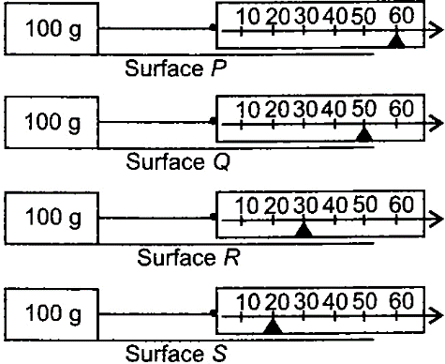

(1) Surface P (2) Surface Q

(3) Surface R (4) Surface S

1. Which of the following objects exerts the maximum pressure on the floor? (All objects have the same mass).

(1) 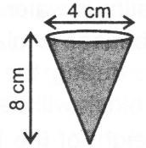 (2) 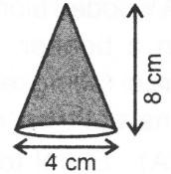

(3) 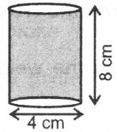 (4) 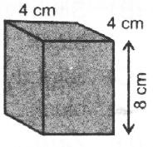

1. A block of mass 10 kg is suspended through two light spring balances as shown in figure. Then
2. Both the scales will read 10kg
3. Both the scales will read 5kg
4. The upper scale will read 10 kg and the lower scale zero
5. The reading may be anything but their sum will be 10 kg.
6. Three identical vessels A, B and C contain same quantity of liquid. In each vessel, blocks with different densities but same masses are placed as shown in figure. If *FA* , *FB* and *FC* are the total forces acting on the base of vessels A, B and C respectively, then

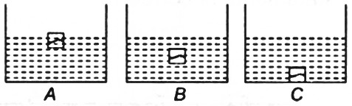

1. 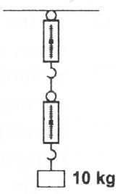*FA*  *FB*  *FC*

(3) *FA*  *FB*  *FC*

1. *FA*  *FB*  *FC*

(4) *FA*  *FB*  *FC*

|  |  |  |  |  |
| --- | --- | --- | --- | --- |
| **Answer key** | | | | |
| **1.** 1 | **2.** 2 | **3.** 2 | **4.** 1 | **5.** 3 |
| **6.** 4 | **7.** 2 | **8.** 3 | **9.** 3 | **10.** 1 |
| **11.** 4 | **12.** 3 | **13.** 4 | **14.** 1 | **15.** 2 |
| **16.** 2 | **17.** 1 | **18.** 1 | **19.** 1 | **20.** 1 |

# HINTS & EXPLANATIONS

1. (a): According to Newton's third law of motion, for every action, there is an equal and opposite reaction.
2. (b): A girl pulling the leash of a running dog makes dog slower; A driver turning the steering wheel of a car is changing the direction of the car; By hitting a nail with a hammer is showing impact force; A ball thrown upwards always comes towards the Earth due to gravity.
3. (b): For X, F =100 N, A =100 cm2

1 1

1. (a): When there is extra pressure applied to any one limb, the liquid in it is forced down and the level in the other limb rises.
2. (d): The wooden block is floating in water. During free fall, weight of block floating in water will be zero, hence no water will be displaced. So up thrust on the block will also be zero.
3. (c): Increase in weight by 50 g, length of spring increases by 2 cm. oppositely decrease in weight by 50 g, length decreases by 2 cm. So original length of spring is 5 cm.
4. (d): Since the extension produced in the spring

 *P*1

 *F*1

*A*1

 100  1*Ncm*2 100

pulled by Puneet is more than that of pulled by Jay.

For *Y*, *F*  100 *N*, *A*

 250*cm*2

So, spring of his striker stores more potential

2 2

 *P*  *F*2  100  0.4 *Ncm*2, *Hence*, *P*  *P*

energy.

*A*2 250

2

1 2 Thus, Puneet's ball will move faster.

1. (a) Not Available
2. (c): The pressure exerted by water in all directions is the same at the same depth. The pressure of the water increases with depth and is independent of the size or shape of the container.
3. (d): The object does not fall because the force exerted by the string, balances the Earth's gravity and net effect of the force on the object is zero.
4. (b): One common error is to think that the pressure at 0.4 h above the surface of the reservoir of mercury is 0.4 times the atmospheric pressure. The pressure at P is caused by the weight of the mercury above point P. The pressure at P

= 0.6 100000 = 60000 Pa

1. (c) Not Available
2. (c): The water pressure at the base of the container is much greater than at the top. So water falls out the farthest through the hole C.
3. (a) Not Available
4. (b) Not Available
5. (b) Not Available
6. (a): The force required to move a 100 g mass on surface P is maximum. This means surface P offers maximum friction.
7. (a) Not Available
8. (a): Weight of an object is the measure of gravitational force on the object. The force acts on the block whose weight is 10 kg and spring balance measures that force which block produces in spring, so, it is same for both.
9. (a): Force acting on the base of vessels A, B and C is the weight of block and weight of water, which is same for all the three vessels. Hence, *FA*  *FB*  *FC* .